  Reading Time: 1 minutes | MATHEMATICS METHODS : UNITS 1 & 2, 2019  Test 2 – (10%)  (1.1.1 – 1.1.28)
Time Allowed  20 minutes |  | First Name Surname | Marks  25 marks

Circle your Teacher’s Name: Mrs Benko Mrs Bestall Mrs Fraser-Jones Mrs Goh Mr Koulianos Mrs Murray Mr Rudland

Assessment Conditions: (N.B. Sufficient working out must be shown to gain full marks)

- Calculators: Not Allowed

- Formula Sheet: Provided

- Notes: Not Allowed

CALCULATOR FREE

- [3 and 3 marks]
Solve:

- $\frac{5y+1}{4}=6-\frac{2y}{3}$

- $x^{2}+2x=15$

- [4 and 5 marks]
Given $x^{3}+3x^{2}-18x-40=(x+a)(bx^{2}+cx-8)$
- Find the value of a, b and c.

- Hence sketch $y=40+18x-3x^{2}-x^{3}$ , showing x and y intercepts.

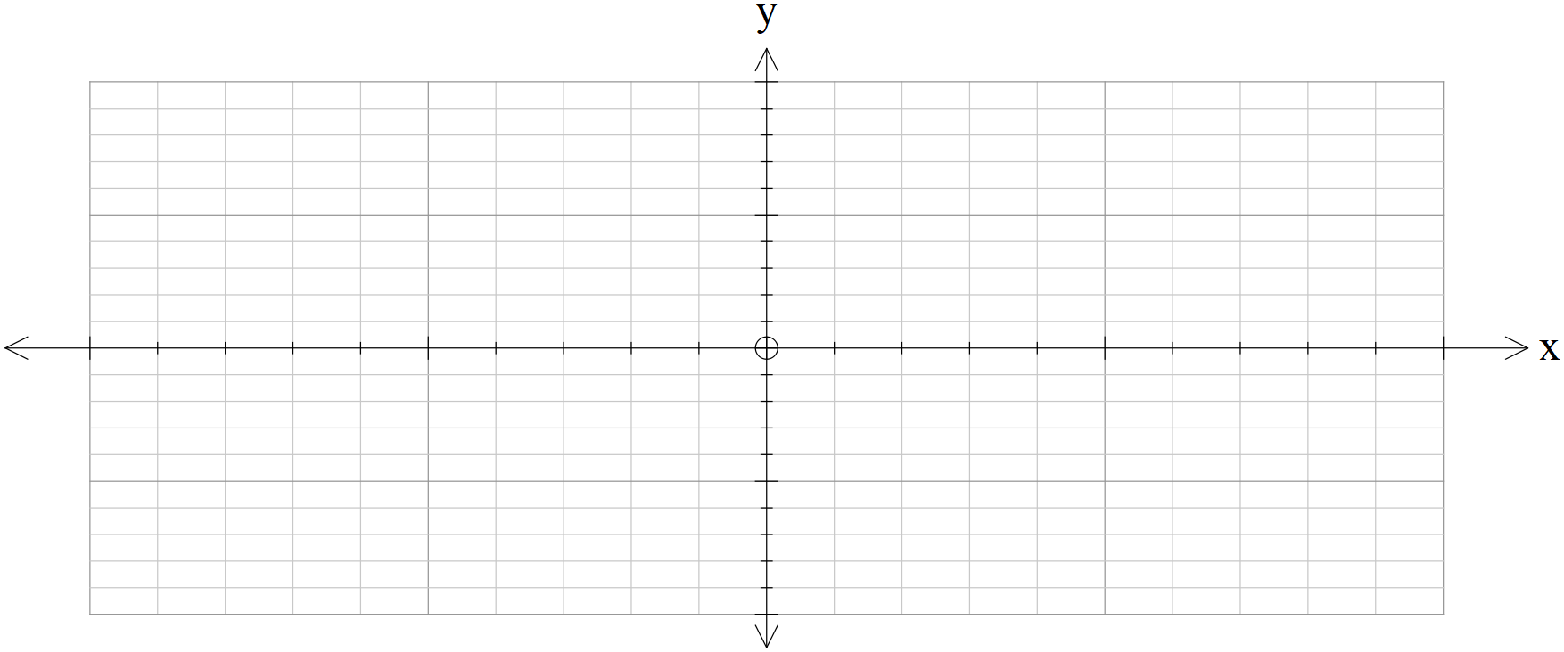

- [10 marks]
Using the graph supplied, find the value of the constants in each of the equations below:
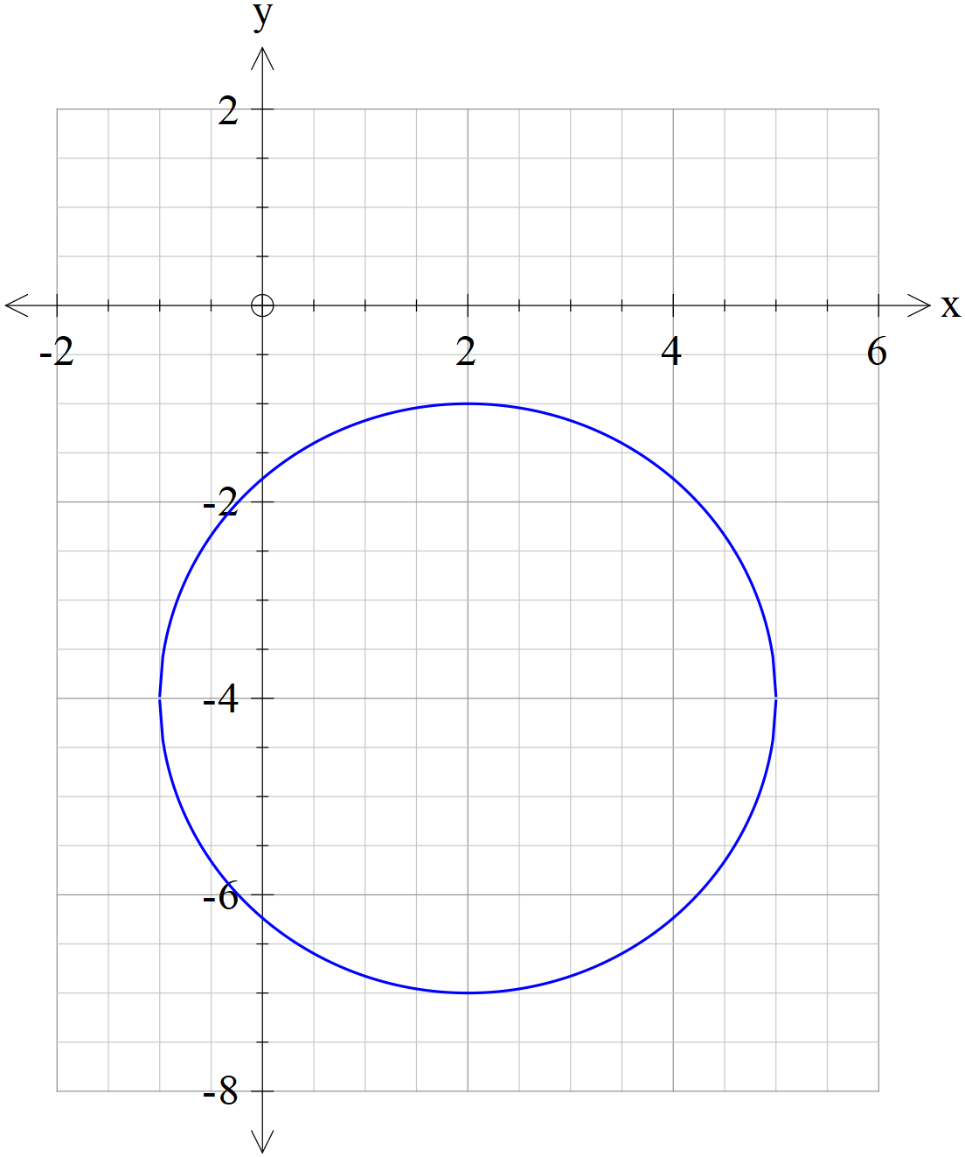  $${\left(x+a\right)}^{2}+{\left(y+b\right)}^{2}=c$$  a =  b =  c = | 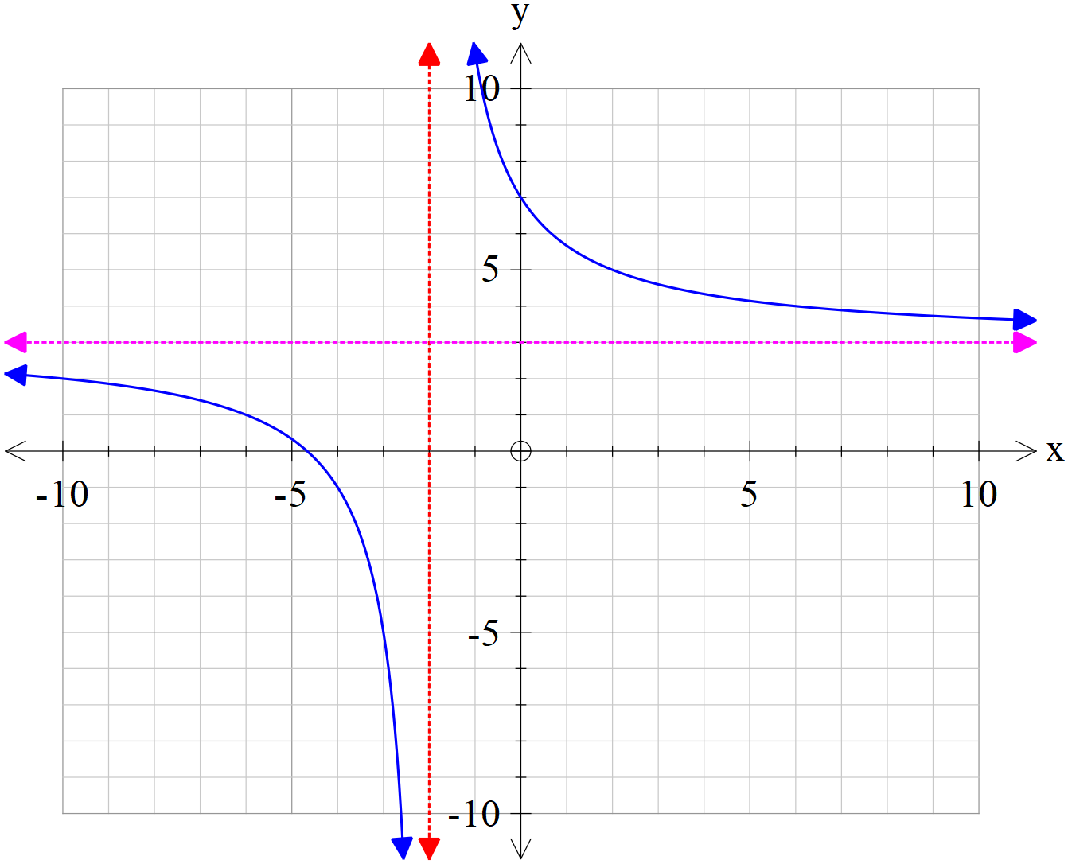  $$y=\frac{d}{x+e}+f$$  d =  e =  f =
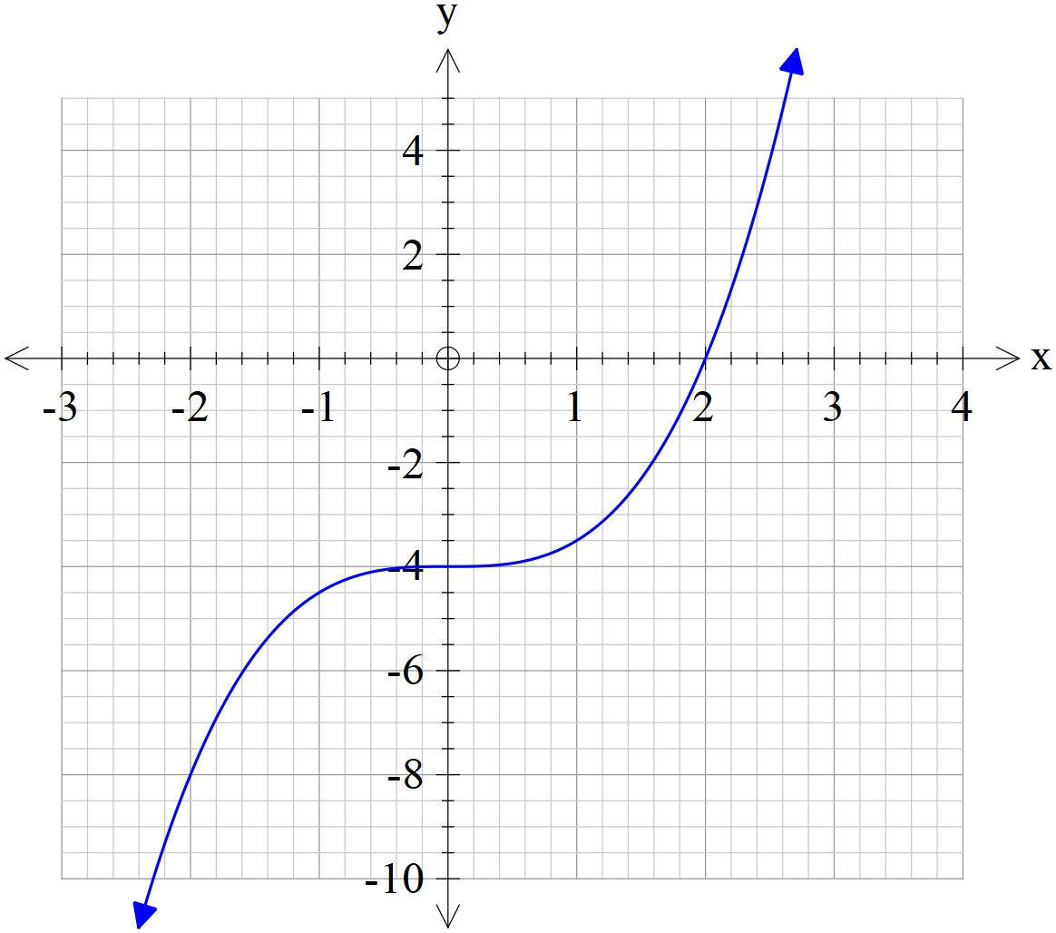  $$y=g{\left(x+h\right)}^{3}+i$$  g =  h =  i = | 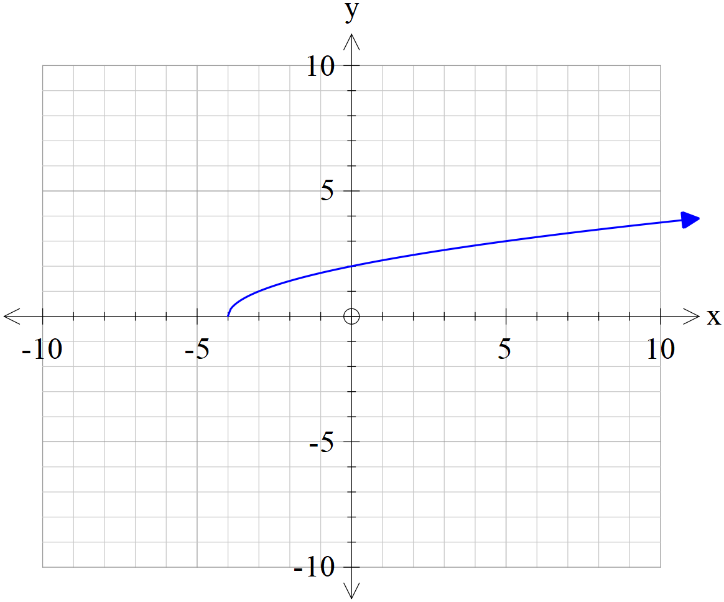  $$y=\sqrt{x+j}$$  j =

  Reading Time: 1 minutes | MATHEMATICS METHODS : UNITS 1 & 2, 2019  Test 2 – (10%)  (1.1.1 – 1.1.28)
Time Allowed  25 minutes |  | First Name Surname | Marks  29 marks

Circle your Teacher’s Name: Mrs Benko Mrs Bestall Mrs Fraser-Jones Mrs Goh Mr Koulianos Mrs Murray Mr Rudland

Assessment Conditions: (N.B. Sufficient working out must be shown to gain full marks)

- Calculators: Allowed

- Formula Sheet: Provided

- Notes: Not Allowed

CALCULATOR Assumed

- [2 marks)
A relation consists of the ordered pairs: (-3,4) ,(-1,5), (0,-2), (1,4) and (6,8). Is the relation a function? Explain.

- [5 marks]
Express $y=4x^{2}+8x-7$ in the form $y=a{\left(x+b\right)}^{2}+c$ and hence give its domain and range.

- [3 marks]
The stress on an object is inversely proportional to its area. If a rectangle measuring 4 metres by 6 metres is under a stress of 60 N/m². Find the stress a 3 m square would encounter with the same force.

- [4 marks]
The equation of the path of a cricket ball is $y=1.1x-\frac{x^{2}}{50}$ where x and y are the horizontal distance travelled and the vertical height respectively in metres. Find, to the nearest the greatest vertical height reached and the horizontal distance travelled.

- [3 marks]
Find the x-intercept of the line parallel to $5x-2y+10=0$ with a y intercept of (0,-7).

- [3 marks]
Find the value(s) of m if the quadratic equation $x^{2}-2mx+3=0$ has only one solution.

- [1, 3, 3 and 2 marks]
A(-8,6), B(a,b), C(5,-7) and D(-5,-3) are the vertices of a quadrilateral with diagonals AC and BD.
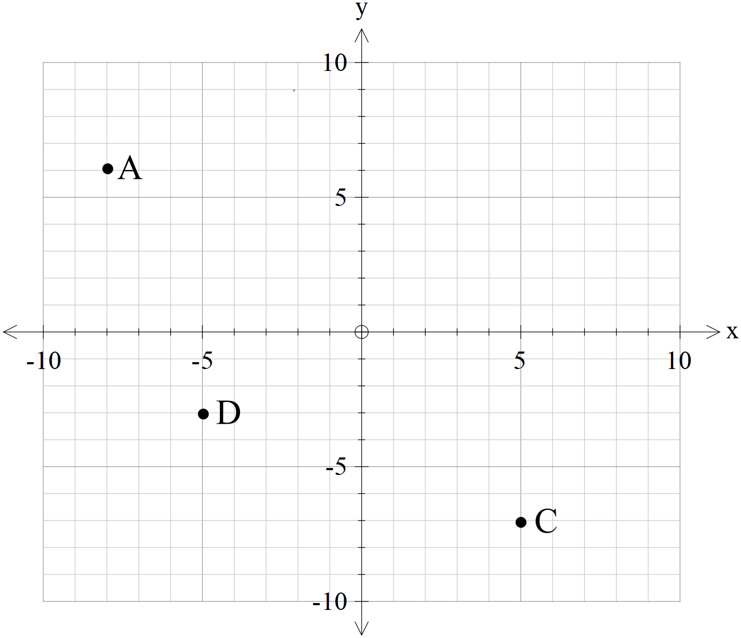
- Find the mid-point of AC.

- Find the co ordinates of B, given the diagonals of ABCD bisect each other.

- Find the equation of the line perpendicular to DC, and passing through D.

- Does B lie on the line found in question c.

